Globe Valve
Operation Manual
1. Scope
This manual covers globe valves with nominal sizes DN6 mm to DN300 mm (1/4" to 12") and nominal pressures PN1.6 MPa to PN16 MPa (ANSI Class 150 to 900), with threaded, flanged, butt-welded, and socket-welded connections, for both manual and electric operation.
2. Purpose
2.1 This globe valve is used for blocking and opening fluid in pipelines.
2.2 Valve body material shall be selected based on the medium:
2.2.1 Carbon steel valves -- suitable for water, steam, and oil media.
2.2.2 Stainless steel valves -- suitable for corrosive media.
2.3 Applicable temperature ranges:
2.3.1 Standard carbon steel valves: -29 C to +425 C
2.3.2 Alloy steel valves: max. 550 C
2.3.3 Stainless steel valves: -196 C to +200 C
3. Structure
3.1 The basic structure of the globe valve is shown in Figure 1.
3.2 The wear-resistant gasket and packing use PTFE or flexible graphite, providing reliable sealing.
4. Operation
For manual valves, rotate the handwheel by hand. For electric valves, the electric actuator drives the stem to rise and lower, driving the disk up and down to open and close the valve. Turning clockwise lowers the disk -- the valve closes. Turning counterclockwise raises the disk -- the valve opens.
5. Storage, Maintenance, Installation, and Use
5.1 Valves shall be stored indoors in a dry and ventilated area. Both pipeline openings shall be sealed.
5.2 Valves stored long-term shall be inspected periodically; remove debris. Pay special attention to keeping the sealing faces clean to prevent damage.
5.3 Before installation, verify that the valve markings match the service requirements.
5.4 Before installation, inspect the valve bore and sealing faces; if any contaminants are present, wipe clean with a soft cloth.
5.5 Before installation, check that the packing is compressed. Ensure the packing maintains its sealing function while not obstructing stem rotation.
5.6 During system or pipeline pressure testing after installation, the valve shall be in the fully open position.
5.7 During operation, regularly apply lubricant to the stem trapezoidal thread.
5.8 For manual valves, use the handwheel directly to open and close. Do not use auxiliary levers or other tools.
5.9 Valves in service shall be inspected periodically. Check the sealing faces, stem, and the condition of gaskets and packing. If any components are damaged or worn, repair or replace them promptly.
5.10 For the storage, maintenance, installation, and use of electric and pneumatic valve actuators, refer to the "Valve Electric Actuator Manual".
6. Possible Faults, Causes, and Resolutions -- See Table 1
Table 1 Possible Faults, Causes, and Resolutions
Possible Fault | Cause | Resolution
Packing leakage | 1. Packing gland not tightened evenly  2. Packing has failed due to prolonged use or improper storage | 1. Tighten nuts evenly to compress packing  2. Replace packing
Leakage between sealing faces | 1. Sealing face contaminated with foreign matter  2. Sealing face damaged | 1. Clean foreign matter from sealing faces  2. Re-machine / repair or replace
Leakage at body-bonnet joint | 1. Joint bolts tightened unevenly  2. Flange sealing face damaged  3. Gasket fractured or failed | 1. Tighten bolts evenly  2. Re-machine the flange face  3. Replace gasket
Handwheel rotates with difficulty / disk fails to open or close | 1. Packing compressed too tightly  2. Packing gland / compression assembly misaligned  3. Stem nut damaged  4. Stem nut thread severely worn or fractured  5. Stem bent | 1. Slightly loosen packing gland nuts  2. Re-align packing gland assembly  3. Replace stem nut  4. Remove fouling; dress threads  5. Straighten or replace stem
Electric / pneumatic actuator fault | See "Valve Electric Actuator Manual" | See "Valve Electric Actuator Manual"
7. Warranty
The manufacturer provides warranty for valves placed into service for up to one (1) year from start of use, but no longer than eighteen (18) months from date of shipment. During the warranty period, any failures attributable to product quality will be repaired or have parts replaced at no charge.
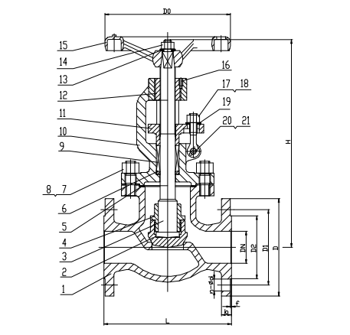
Figure 1 Manual Flanged Globe Valve


WEIZIDOM GROUP
www.wsdvalves.com
South City, Longhu Town, Xinzheng City,
Zhengzhou City, Henan Province, China

